**SHRI SHAMBHUBHAI V. PATEL COLLEGE**

**OF COMPUTER SCIENCE & BUSINESS**

**MANAGEMENT**

**VEER NARMAD SOUTH GUJARAT**

**UNIVERSITY**

**(VNSGU)**

**PROJECT REPORT**

**ON**

**FlowShop – The Flower Delivery App**

**As Partial Requirement for the**

**B.C.A 5th Semester**

**Year: 2022-2023**

**SUBMITTED BY:**

**Vagadiya Bhargav Hasmukhbhai**

**GUIDE BY:**

**Asst.Prof Sweety Patel**

***Acknowledgement***

*The reason of completing the project work successfully is not just efforts but efforts by many people. The people, who trusted, guided us and encouraged us.*

*Guide is the person who provides you direction towards success, so I feel great Pleasure to express my gratitude to our guides and also other faculty as well as every as well as ever person who helped us by giving their valuable suggestions.*

*I would like to first thanks Prof. Sweety ma’am and Other BCA staff members heart-fully, who granted us to do this project and also provided their advices.*

*Finally, I wish to express out thanks to all those people who helped us directly or indirectly to complete this work.*

***From,***

*Bhargav Vagadiya*

***INDEX***

1.Introduction 5

1.1 Project Profile 5

1.2 About Project 6

1.3 Requirement Gathering 7

1.3.1 Hardware Requirement 7

1.3.2 Software Requirement 7

2.Objectives 8

3.System Flow Chart 9

4. Data Flow Diagram (DFD) 10

4.1 0-level DFD 10

4.2 1st level DFD 11

4.3 2nd level DFD for Manage User Profile 12

5. Entity Relationship Diagram 13

6. Screenshots 14

7. References 26

# 1.Introduction

**1.1 Project Profile**

**1.2 About Project**

**1.3 Requirement Gathering**

## 1.1 Project Profile

|  |  |
| --- | --- |
| **PROJECT TITLE** | *FlowShop – The Flower Delivery App* |
| **PROJECT TYPE** | *Mobile Application* |
| **FRONTEND** | *Flutter* |
| **BACKEND** | *SQLite* |
| **OPERATING SYSTEM** | *Android* |
| **INTERNAL GUIDE** | *Asst.Prof Sweety Patel* |
| **DEVELOPED BY** | *Bhargav Vagadiya* |

## 1.2 About Project

* **Project Definition**

The Flowshop – The Flower delivery app is a Fresh Flower purchasing app that will help you to choosing a Very Wonderful flower and ordering them with traking.

This Mobile application is made in the latest and Powerful Google’s Framework Flutter. So that the user is feeling safe to use our app without any worry.

* **Features**

* Login Screen where Authorized User can view and purchase the flowers
* Registration Screen where New User can Register yourself and then view and purchase the flowers
* Home Screen where user can show new or Best-selling flowers
* A Menu with Greeting User Attached to Home Page that user can navigate to another screen Easily
* A Search facility to user that can search the product easily at Home Screen
* A Profile Screen where user can view or change their data
* A Change Password Screen where user can change their password
* A Product Screen where user can know the product details in depth and also add product into cart and add product to Wishlist
* A Wishlist Screen where user can show their favorite product
* A My Cart Screen where user can view their cart product and change product quantity or remove the cart product or purchase a cart products at a time.
* last but not least, in my order screen, user can view the ordered products anywhere, any time

## 1.3 Requirement Gathering

### 1.3.1 Hardware Requirement

|  |  |
| --- | --- |
| **PROCESSOR** | Intel(R) Core(TM) i5 CPU above 8 gen |
| **RAM** | 8.00 GB |
| **HARDDISK** | 50 GB |

### 1.3.2 Software Requirement

|  |  |
| --- | --- |
| **OPERATING SYSTEM** | Emulator: Android 8 or above  Pc: windows 10 or above |
| **FRONTEND** | Flutter |
| **BACKEND** | SQLite |
| **IDE** | Android Studio |

# 2.Objectives

* The main objective of this app to user can view , purchase and manage the purchased item.
* It can handle the details of User’s for authentication and store user data in SQLite.

# 3.System Flow Chart

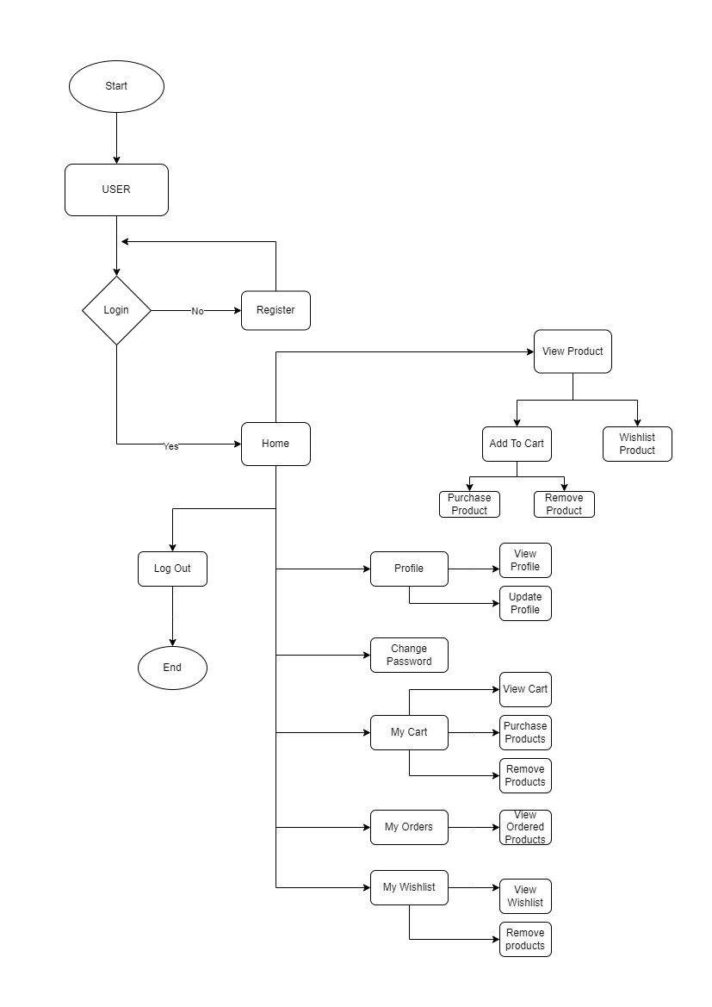

# 4. Data Flow Diagram (DFD)

## 4.1 0-level DFD

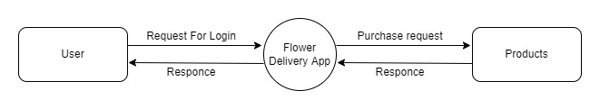

## 4.2 1st level DFD

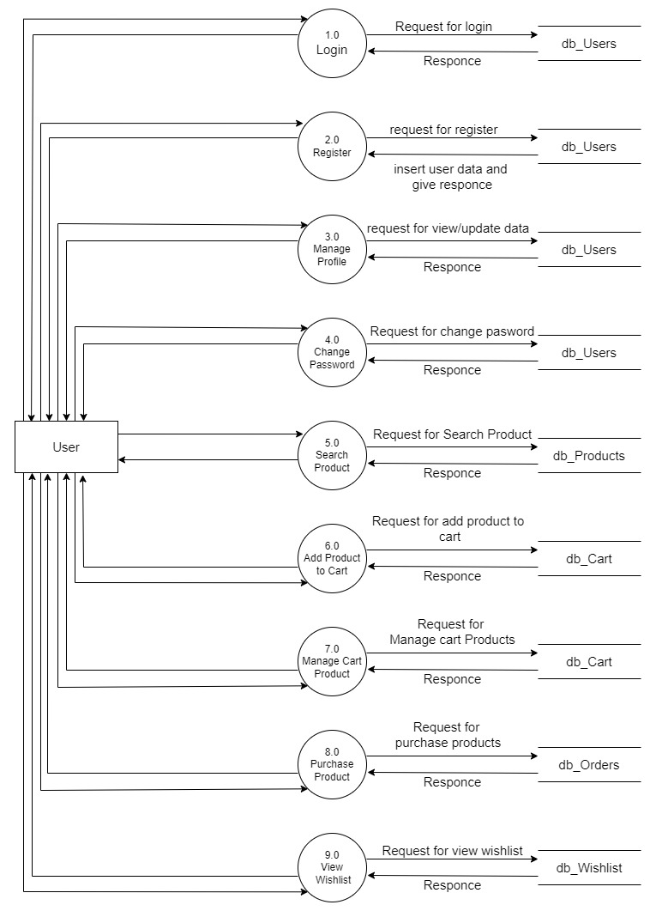

## 4.3 2nd level DFD for Manage User Profile

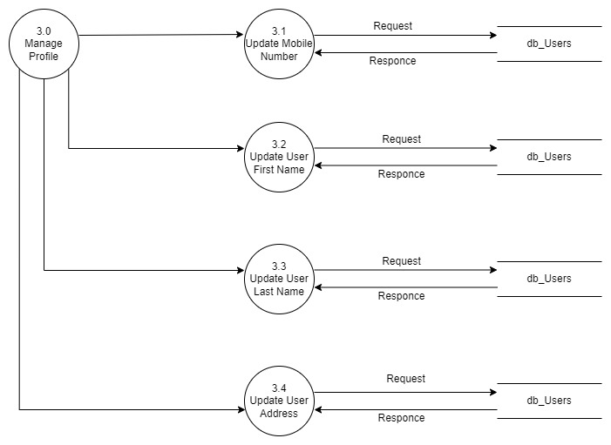

# 5. Entity Relationship Diagram

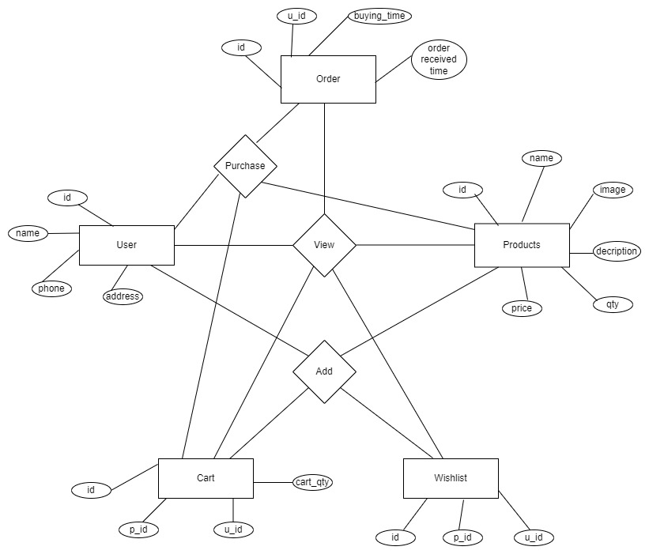

# 6. Screenshots

**Login Screen**

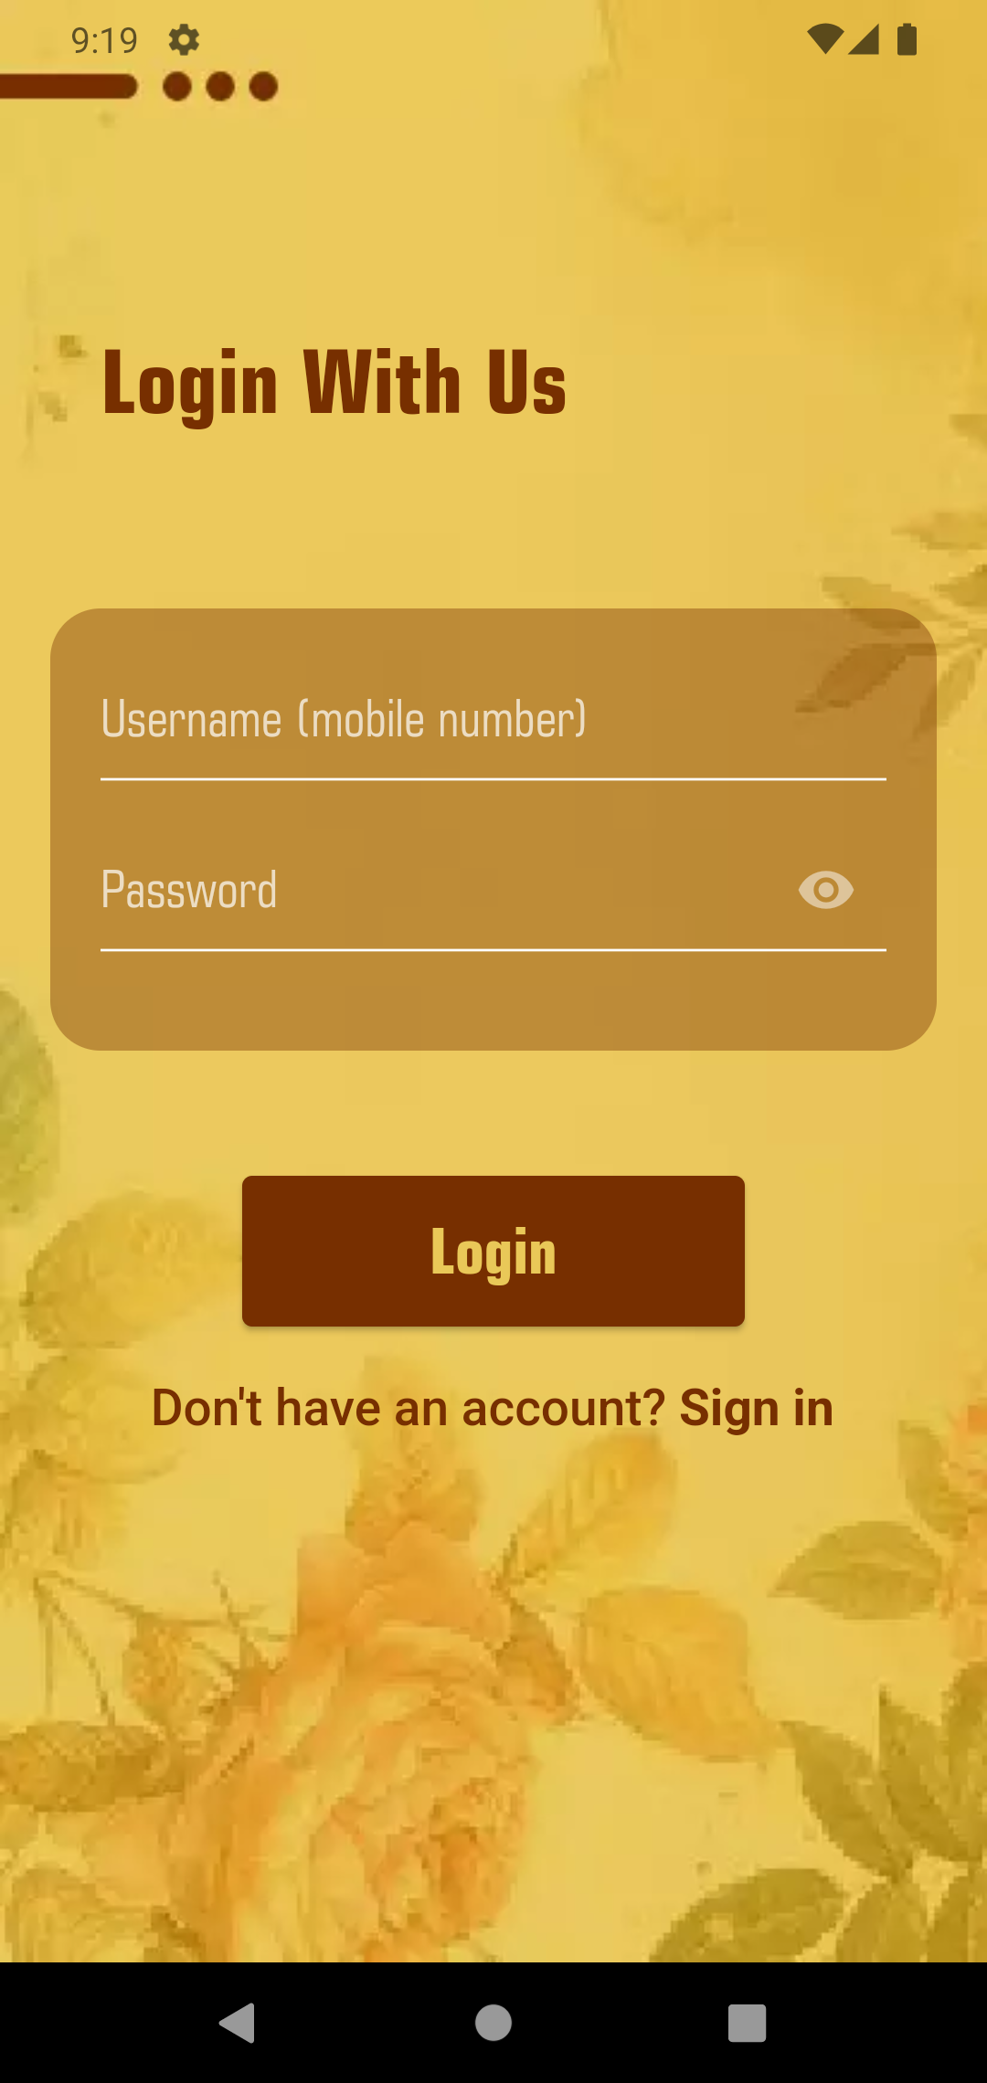

**Registration Screen**

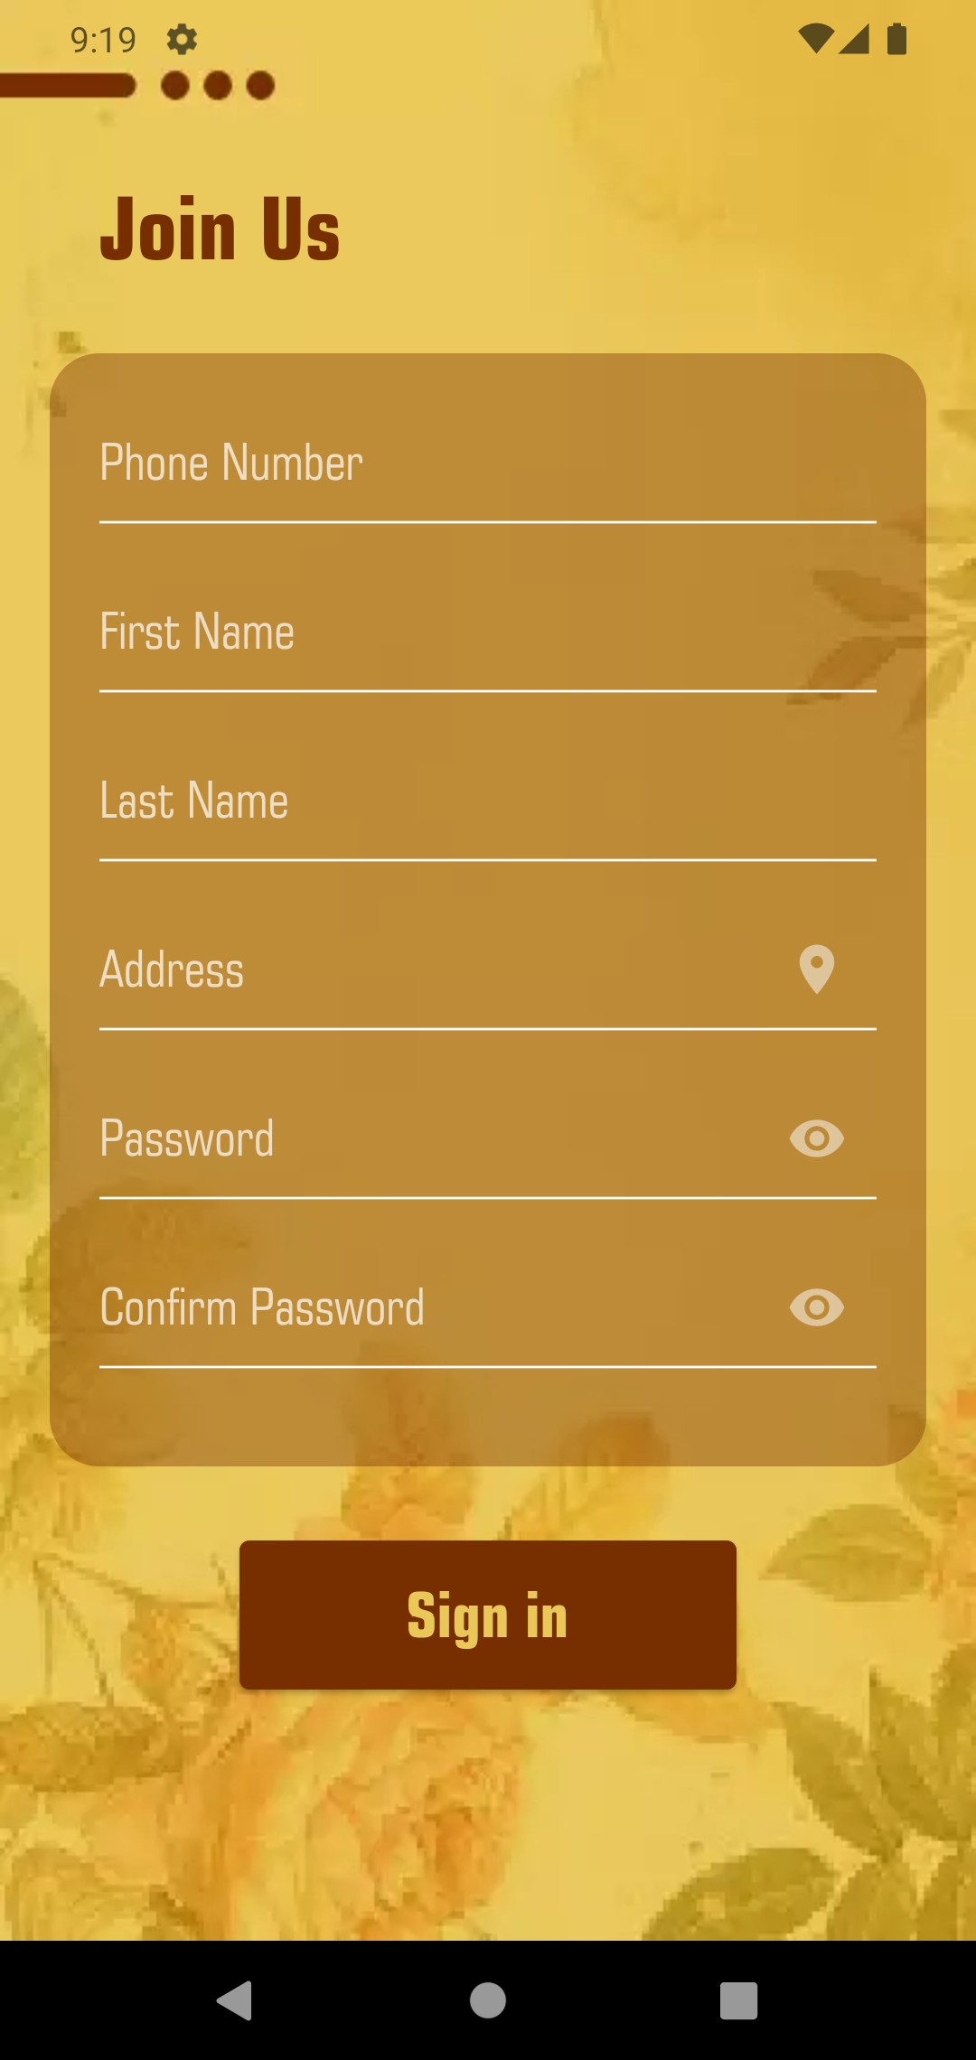

**Home Screen**

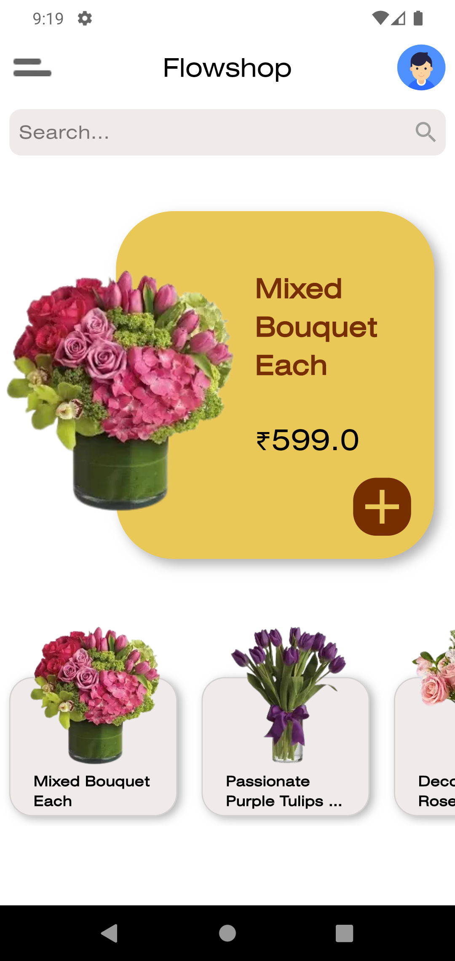

**Search Screen**

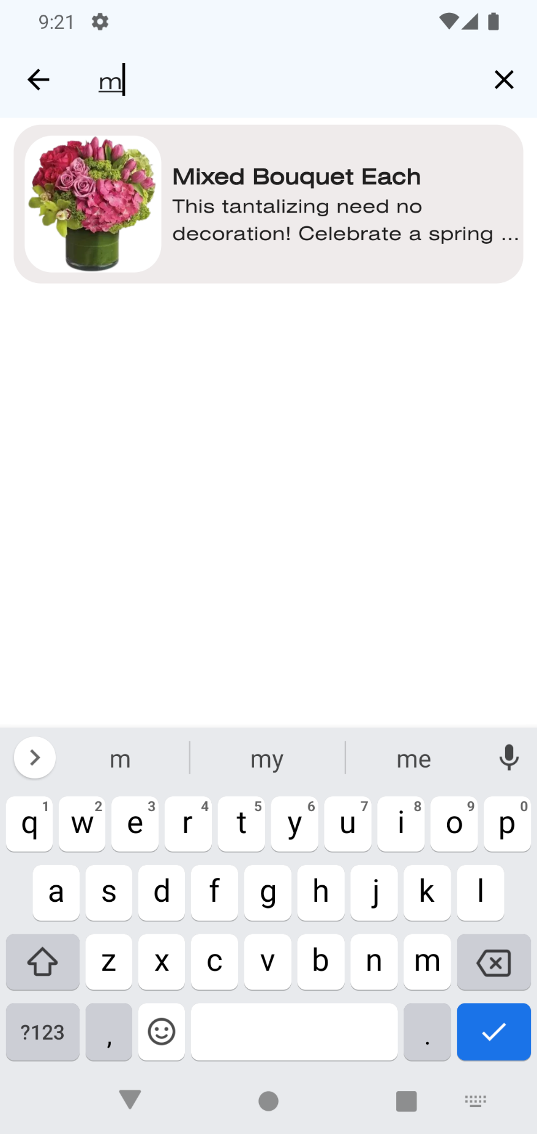

**Menu**

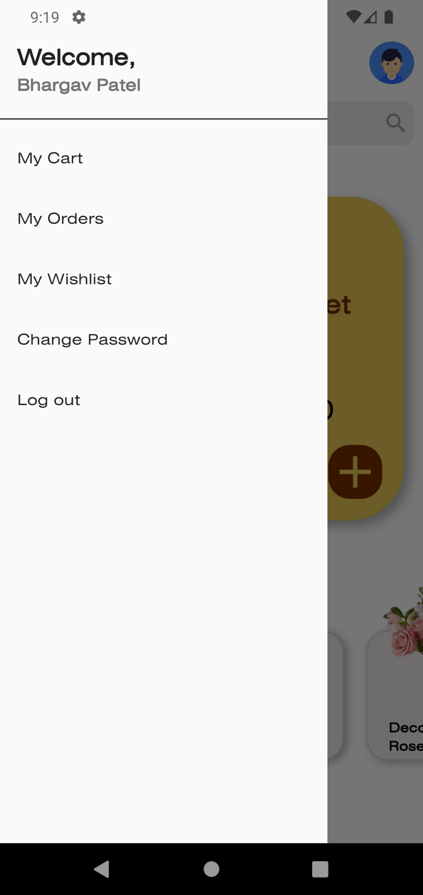

**My Profile**

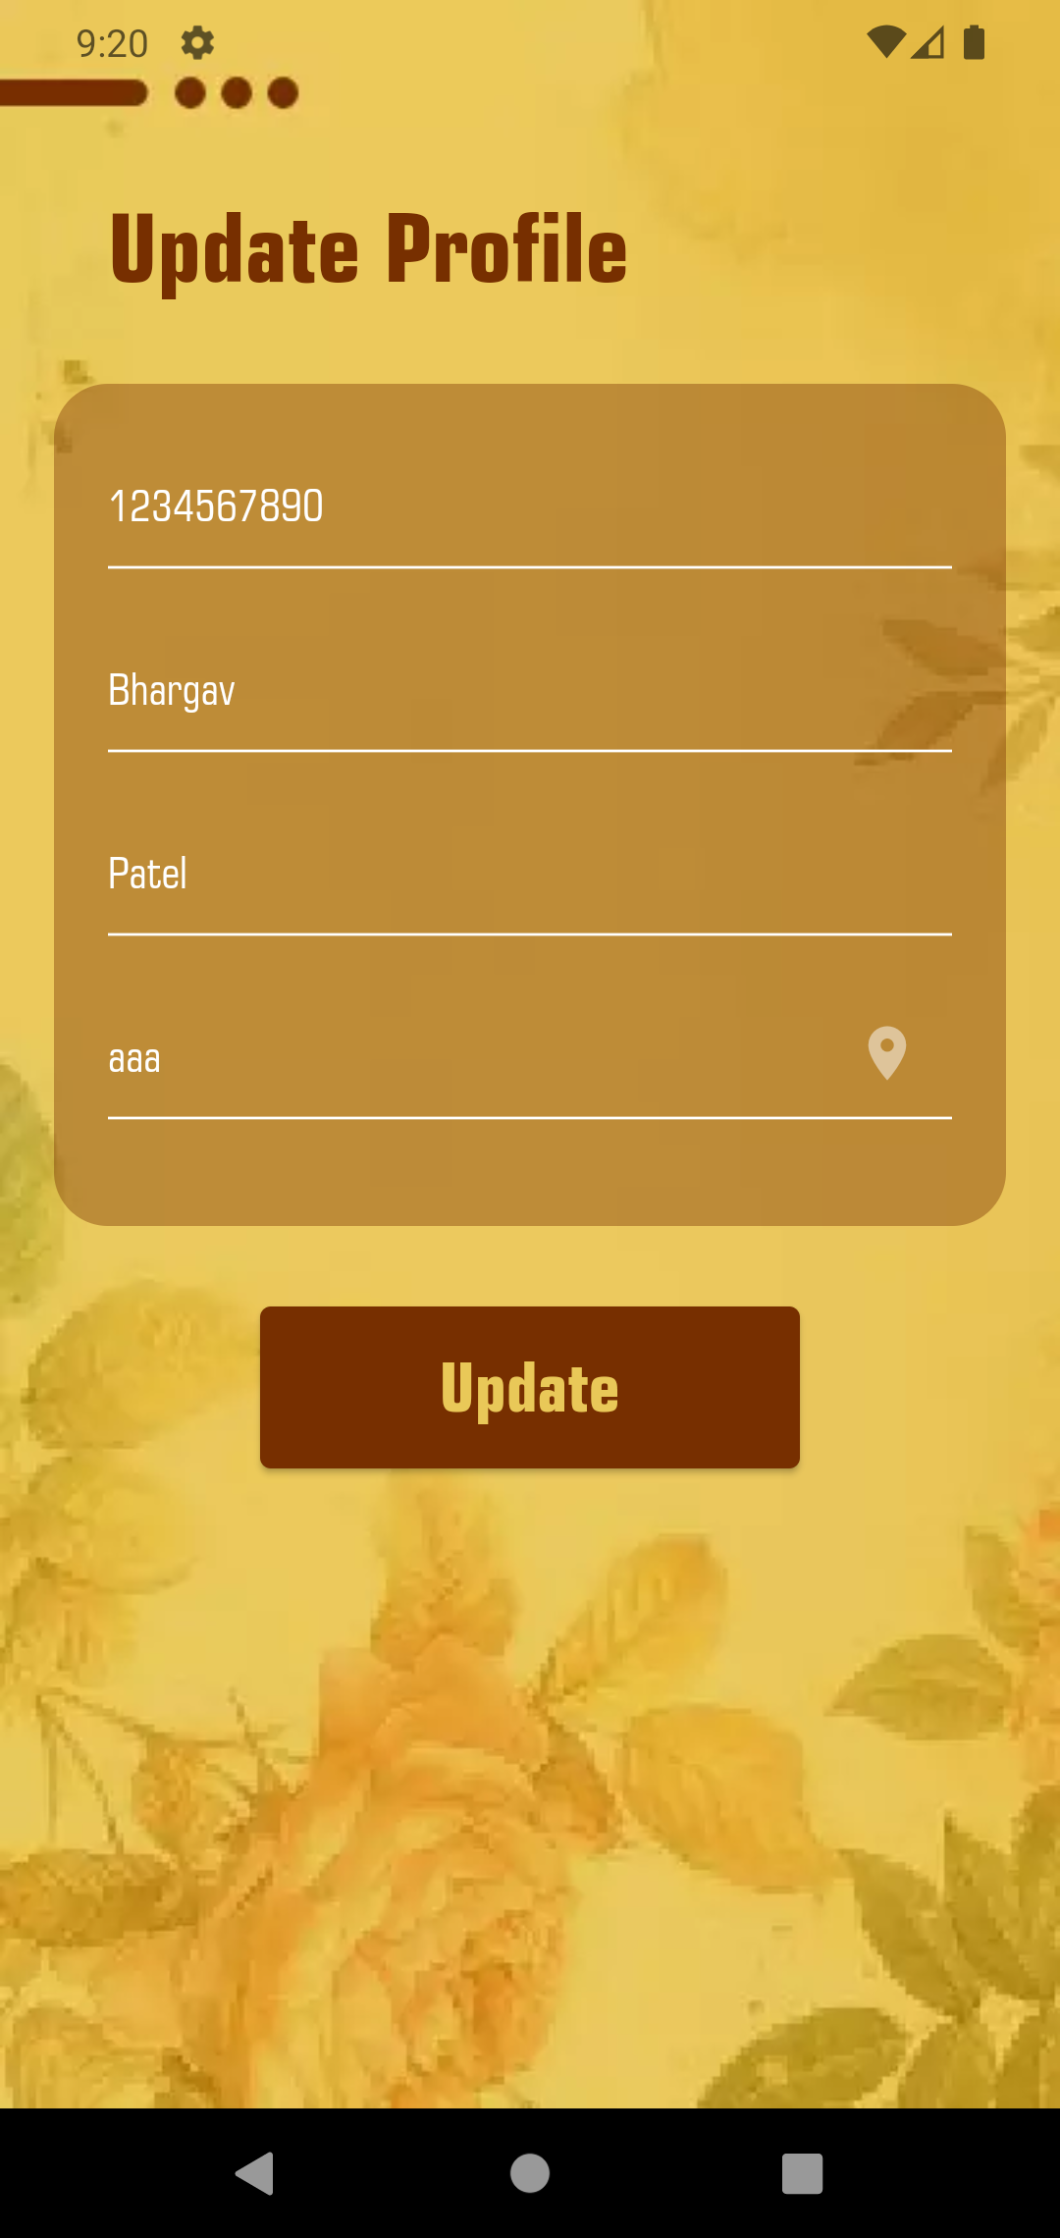

**Change Password**

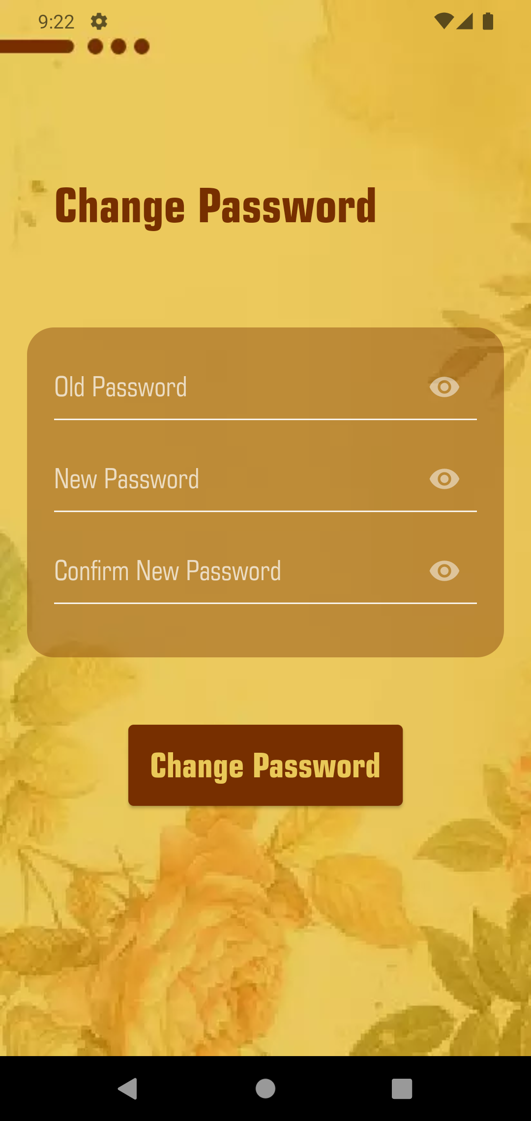

**Product Screen**

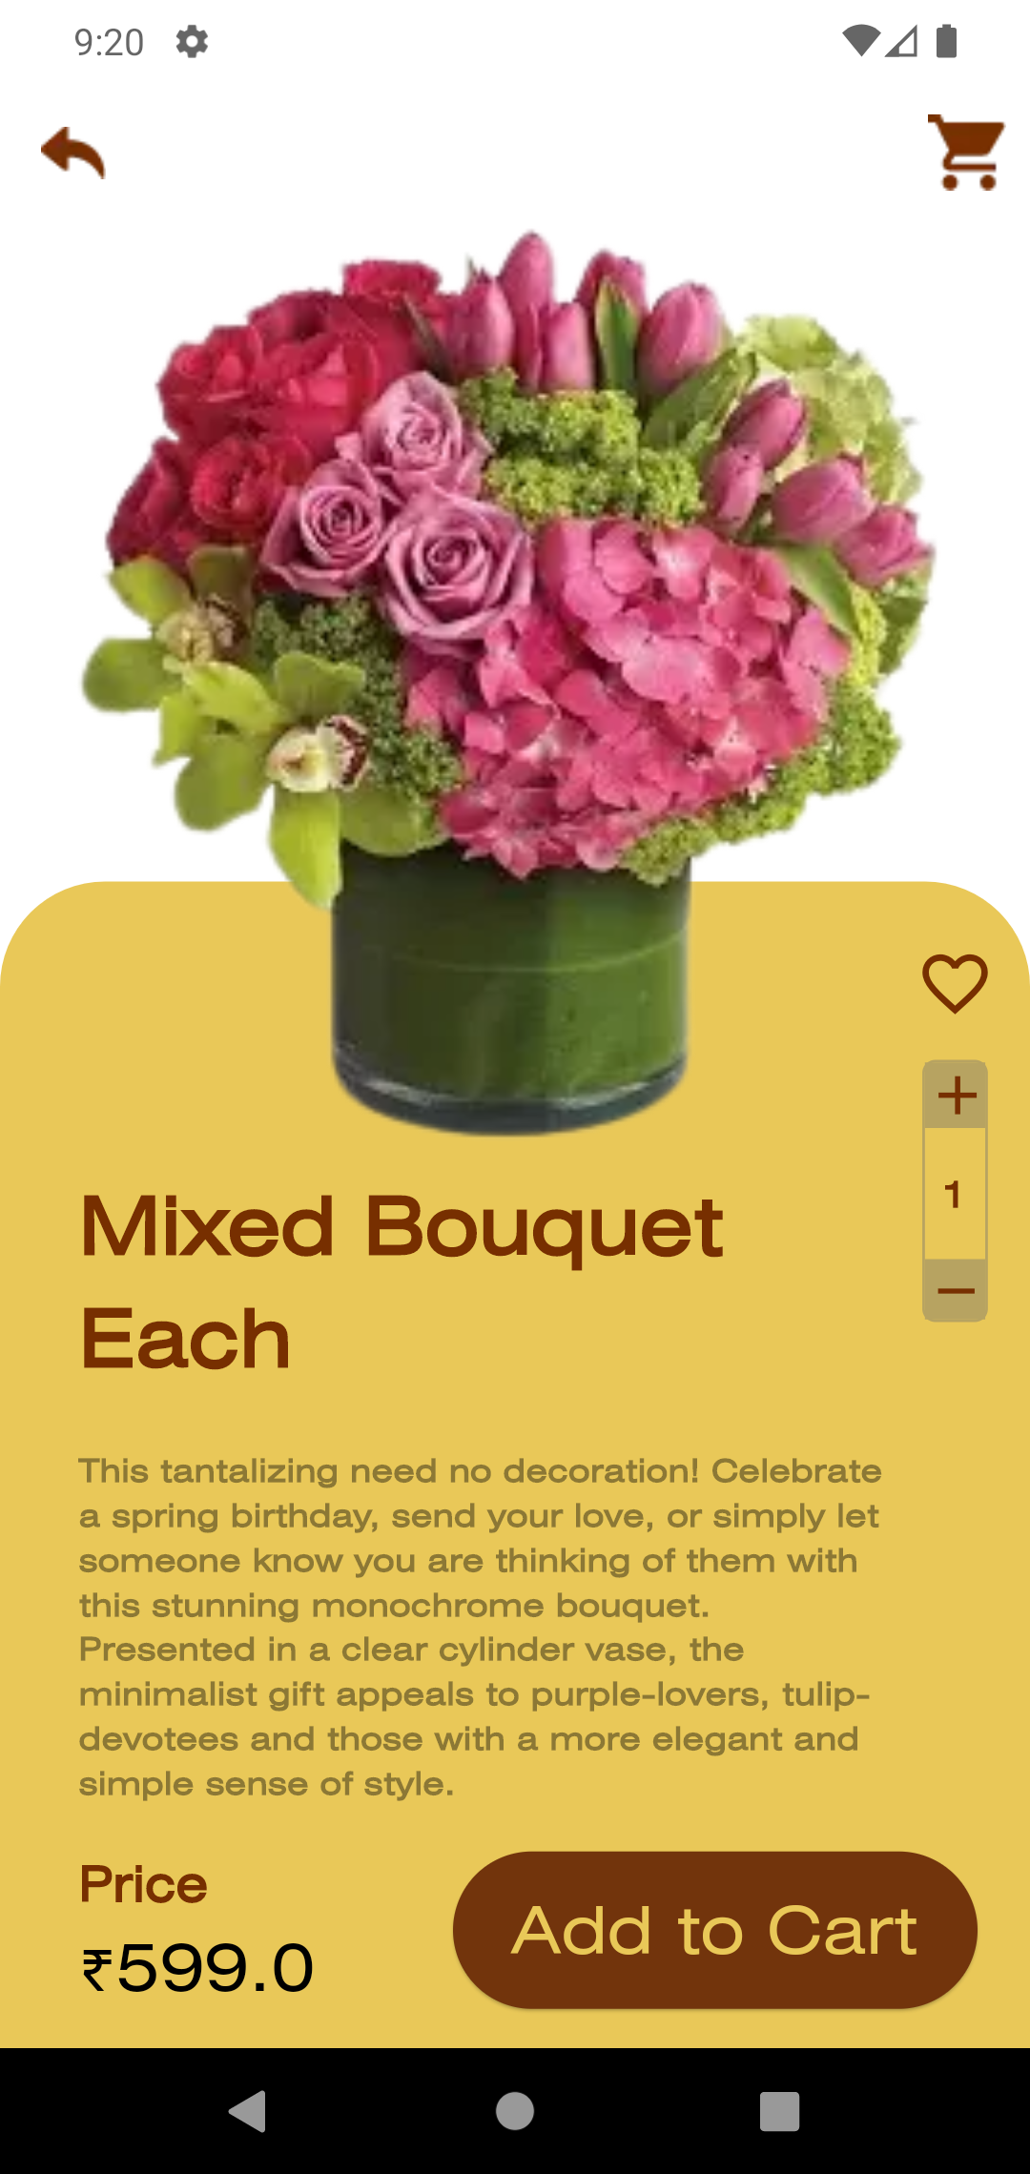

**Wishlist Screen**

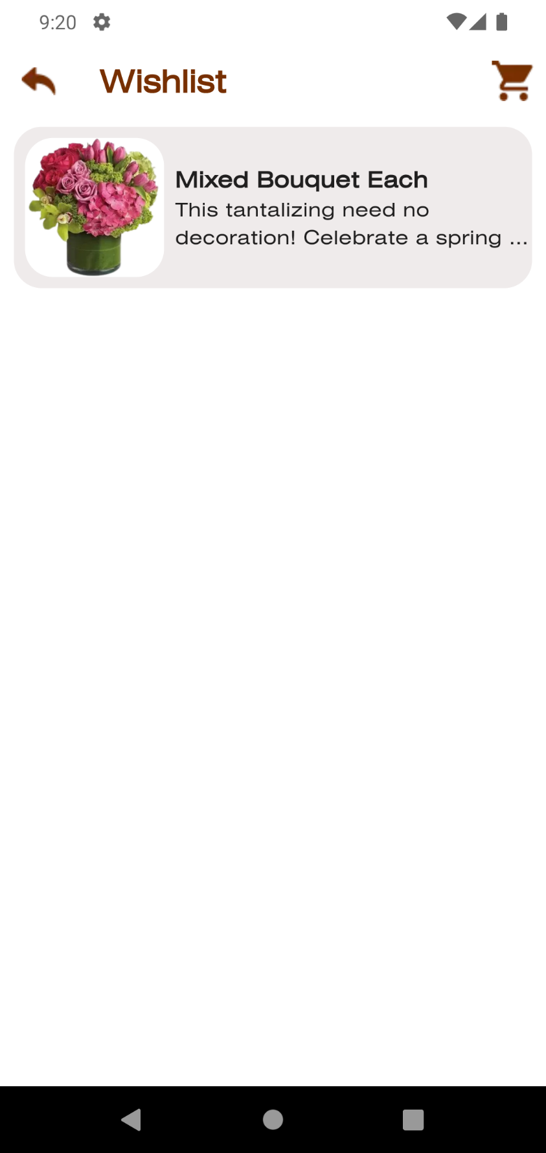

**Cart Screen**

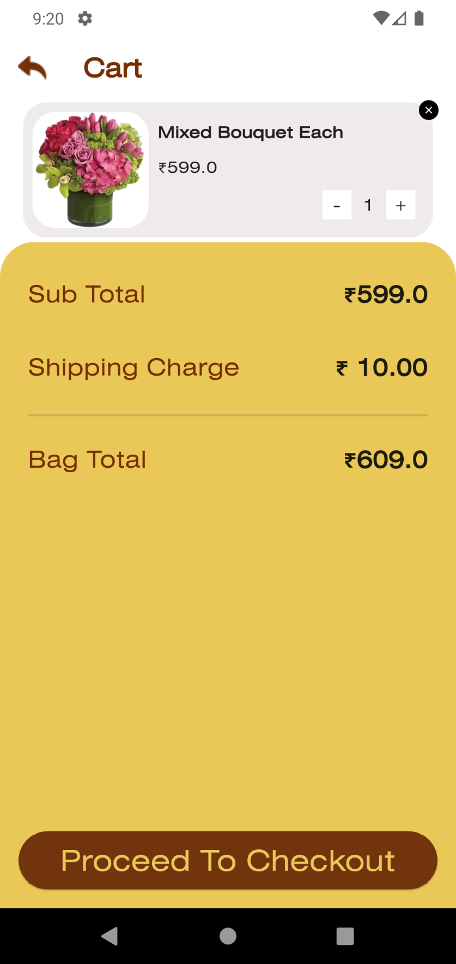

**Order Tracking Screen**

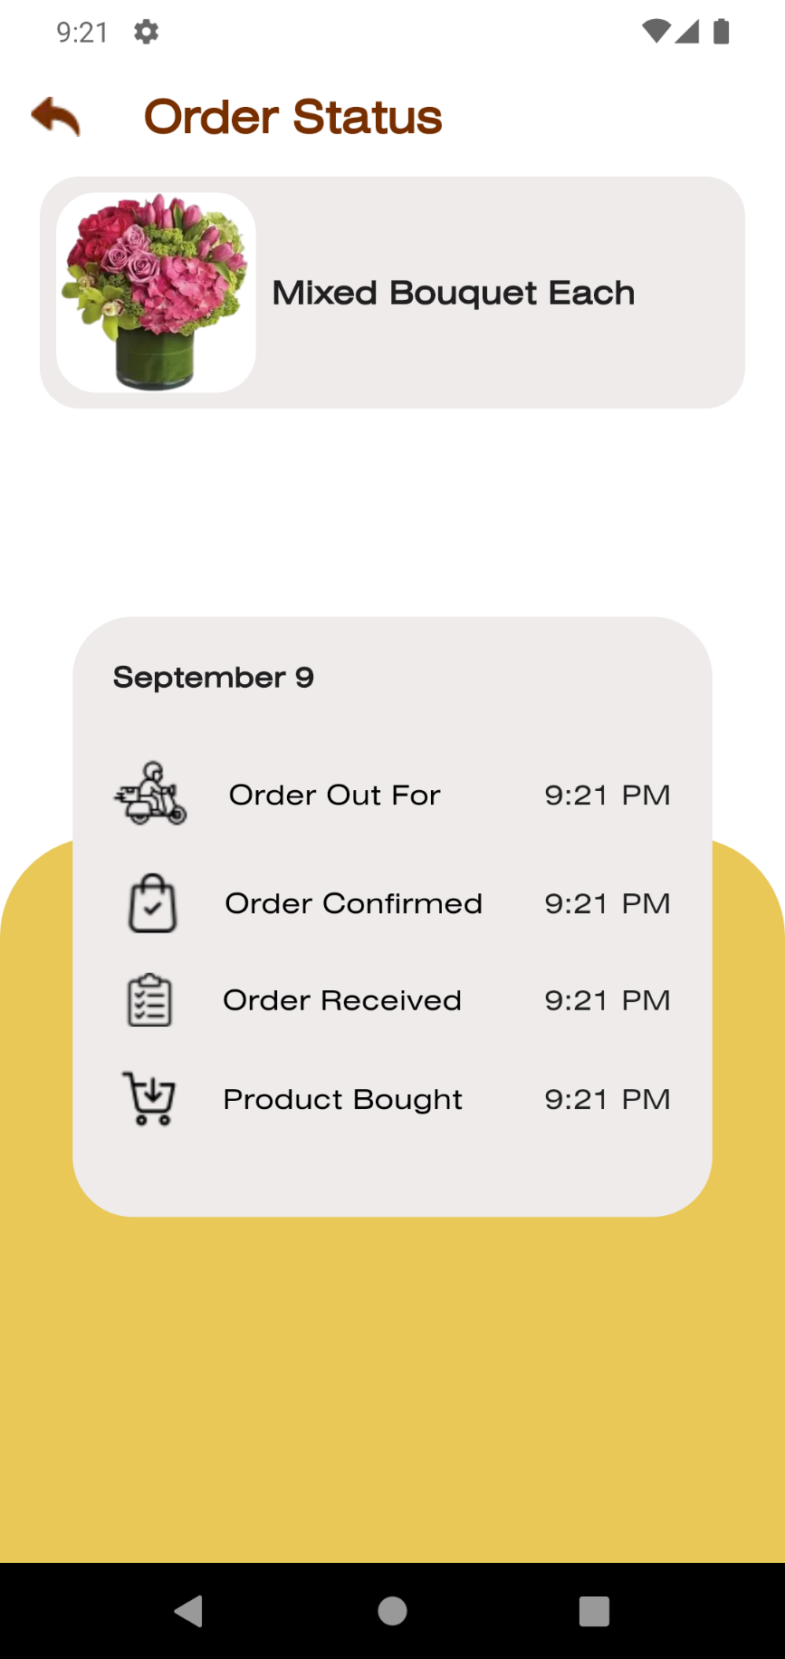

**My Orders Screen**

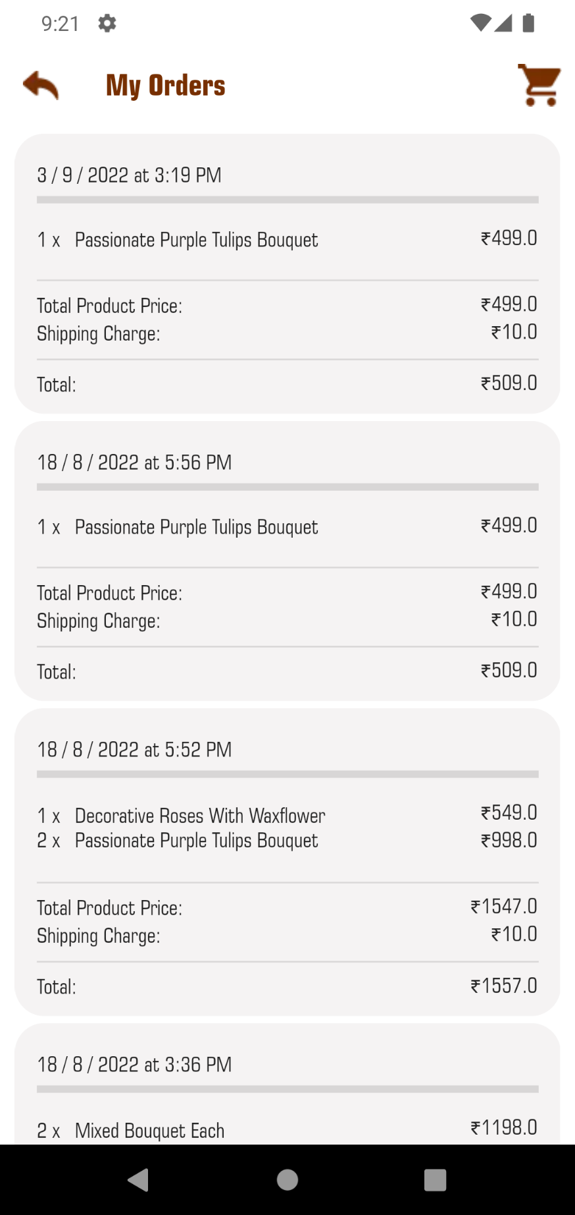

# 7. References

* Flower Product reference: <https://www.teleflora.com/>
* Coding Reference: 1. <https://stackoverflow.com/questions/tagged/flutter>

2. [https://flutter.dev/](https://pub.dev/)

3. <https://www.youtube.com/>

* SQLite Package: <https://pub.dev/packages/sqflite>